**Project Development**

**Sprint-1**

|  |  |
| --- | --- |
| **Team ID** | PNT2022TMID02439 |
| **Project Name** | Project -Smart farmer-IOT enabled smart Farming Application |
| **Team Members** | Kamesh Kumar K , Kaviyaraj C , Javeed Akram Z , KavinSaran JK |

**Python Code:**

import wiotp.sdk.device import time import os import datetime import random myconfig = {

"identity": {

"orgId": "ga4sjl",

"typeId": "NodeMCU",

"deviceId": "12345"

},

"auth": {

"token": "CK2!+2FzgnyZFWE9yW"

}

}

client = wiotp.sdk.device.DeviceClient(config=myconfig, logHandlers=None) client.connect() def myCommandCallback(cmd):

print("Message received from IBM IoT platform: %s" % cmd.data['command']) m=cmd.data['command'] if(m=="motoron"): print("motor is switched on")

elif(m=="motoroff"):

print("motor is switched OFF") print(" ")

while True:

soil=random.randint(0,100) temp=random.randint(-20,125) hum=random.randint(0,100) myData={'soilmoisture':soil, 'temperature' :temp, 'humidity' :hum} client.publishEvent(eventId="status", msgFormat="json", data=myData, qos=0,

onPublish=None) print("Published data Successfully: %s", myData) time.sleep(2) client.myCommandCallback = myCommandCallback

client.disconnect ()

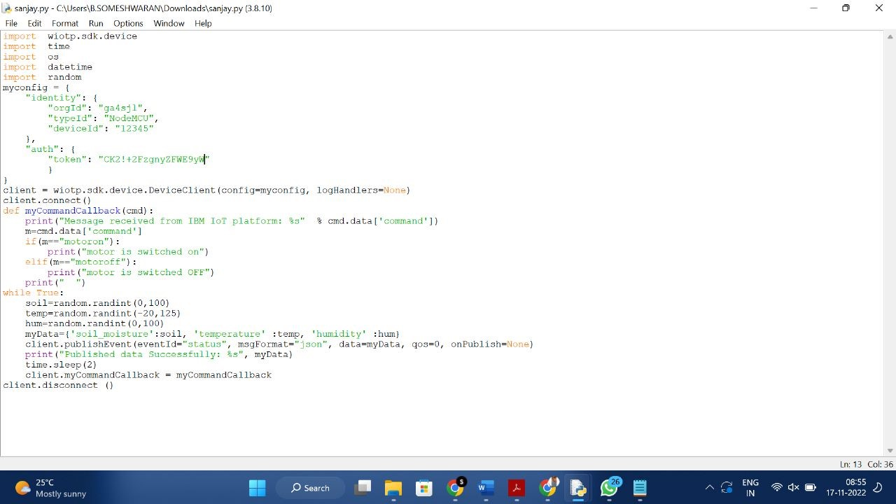

**Running Of Code:**

